Prediction of house prices using different neural network regression models

Saatwik Bisaria
Machine learning(Intern)
AITS
New Delhi,India
saatwik6656@gmail.com

Abstract—House prices increase every year, so there is a need for a system to predict house prices in the future. House price prediction can help the developer determine the selling price of a house and can help the customer to arrange the right time to purchase a house.

Introduction
The real estate market is one of the most competitive in terms of pricing and the same tends to vary significantly based on a lot of factors, hence it becomes one of the prime fields to apply the concepts of machine learning to optimize and predict the prices with high accuracy. Neural network regression models are being used in this project for prediction of house prices. The models being used are of a 3 layer neural network regression, 5 layer neural network regression, and a keras regressor 3 layer model.

Dataset
The dataset being used in this project is available on kaggle. There are 80 features available in the used dataset.

Keras
Keras is an API used for running high-level neural networks. The model runs on top of TensorFlow, and was developed by Google.
Dense implements the operation:
output = activation(dot(input, kernel) + bias) (1)
where activation is the element-wise activation function passed as the activation argument, kernel is a weights matrix created by the layer, and bias is a bias vector created by the layer (only applicable if use_bias is True).

MAE calculate the average of absolute error for each predicted result. MAE is useful when measuring errors in certain units. MAE values can be calculated using

.MAE = ∑ (x_{i} – x)./n (2)

RMSE is used to calculate predicted performance by considering the prediction error of each data. RMSE formula can be seen there –

RMSE = √ ∑ (x_{i} – x)^2./n (3)

Accuracy is the measure of performance of the model. It tells how well the model is predicting the house pricing.

Accuracy=100-∑(ypred –y)./y*100 (4)

Neural Network modelling
After preprocessing the data and converting it into usable form. 3 different models are applied on the data to identify the best model suitable for prediction of house pricing.

- MODEL 1 (3 layer neural network):
Layer (type) Output Shape Param #
=================================================================
dense (Dense) (None, 32) 8416
_________________________________________________________________
dense_1 (Dense) (None, 16) 528
_________________________________________________________________
dense_2 (Dense) (None, 1) 17

- MODEL 2 (Keras regressor based) :

Layer (type) Output Shape Param #
=================================================================
dense_3 (Dense) (None, 32) 8416
_________________________________________________________________
dense_4 (Dense) (None, 16) 528
_________________________________________________________________
dense_5 (Dense) (None, 1) 17

- MODEL 3 (5 layer neural network):

Layer (type) Output Shape Param #
=================================================================
dense_6 (Dense) (None, 128) 33664
_________________________________________________________________
dense_7 (Dense) (None, 128) 16512
_________________________________________________________________
dense_8 (Dense) (None, 32) 4128
_________________________________________________________________
dense_9 (Dense) (None, 16) 528
_________________________________________________________________
dense_10 (Dense) (None, 1) 17
===========================================

MODELS | metrics
MODELS | Accuracy | Loss | Mean Squared Error | Mean absolute error
MODEL 1  (3-Layer) | 94.66815680044856 | 0.4521 | 0.4521 | 0.5474
MODEL 2  (3-Layer KerasRegressor) | 98.83893840617066 | 0.0878 | 0.0878 | 0.2041
MODEL 3  (5-Layer ) | 93.8858 | 1.0695 | 1.0695 | 1.2947

- Metrics of the different models used.

It is found that 3 – layer kerasregressor model has the highest at the time of making this project. The accuracies may change depending on the system used. However , A 3-layer neural network based keras regressor is recommended to be used for prediction of hose pricing

Methodology
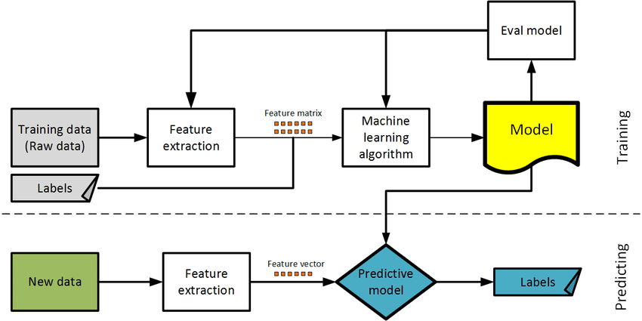

Acknowledgment
I would like to thank AITS for assigning me this project as a part of my internship and my fellow colleagues for the motivation and enthusiasm to complete this project

References
The following resources were referred to while making this project.

- https://keras.io/layers/core/
- https://www.tensorflow.org/tutorials/keras/basic_regression
- https://www.kaggle.com/c/house-prices-advanced-regression-techniques/data
- “The Complete Reference Python” By Martin C. Brown
- Adyan Nur Alfiyatin, Hilman Taufiq, Ruth Ema Febrita, and Wayan Firdaus Mahmudy, “Modeling House Price Prediction using Regression Analysis and Particle Swarm Optimization,” (IJACSA) International Journal of Advanced Computer Science and Applications, Vol. 8, No. 10, 2017
- R Manjula, Shubham Jain, Sharad Srivastava and Pranav Rajiv Kher,”real estate value prediction using multivariate regression models” IOP publishing ltd

IEEE conference templates contain guidance text for composing and formatting conference papers. Please ensure that all template text is removed from your conference paper prior to submission to the conference. Failure to remove template text from your paper may result in your paper not being published.

